LMGC Member’s Online Module User Registration

The steps you will need to take:

You must register to use the online payment system
Member validation is:
First, Last, Member#. (First name is exactly as you see on your dues invoice from the treasurer)
Then you will be prompted for a username and password.
- Username at least 3 characters with no specials characters (&, #, etc.)
- Pwd14 characters, at least one letter, number and special character
Create your account.
Subsequent usage, enter username and password to login.

Instructions if needed

Go to the homepage of LMGC website and select Member Login

For your first time, you will need to select member registration.

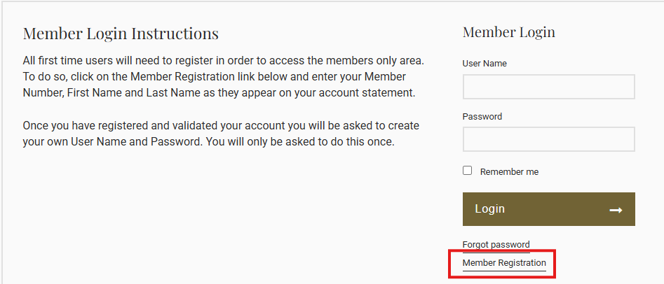

From here you will need to enter your member number, first name and last name as it appears on your monthly invoice. Once entered, select Validate to confirm that what you entered matches what is in Jonas member profile.

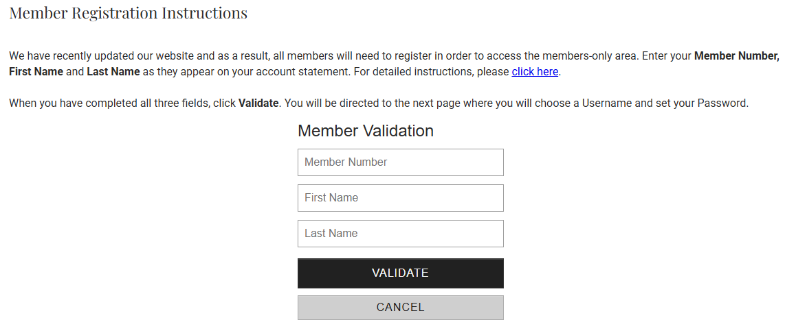
If you need additional information, you can select click here for further details
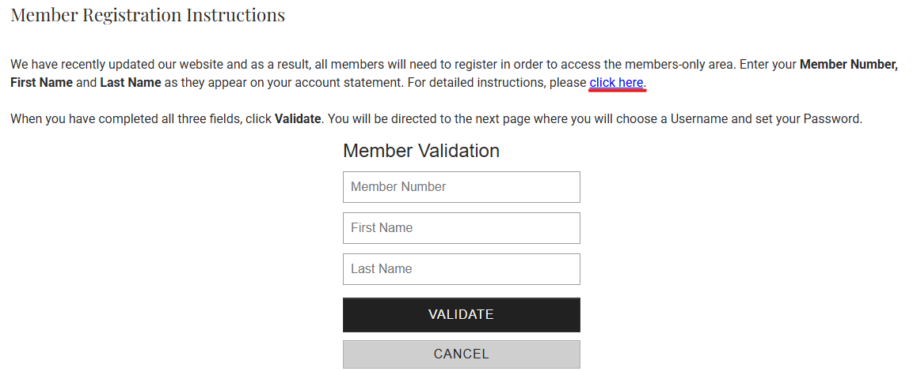

Your username must be at least 3 characters. Your password is 14 characters with at least 1 letter, number and special character.
Regarding entering your email during registration… four scenarios of registration based on your email on file:
- Valid home email address is in Jonas. Select your home email address.
- Valid business email address in Jonas. Select your business email address.
- No email on file in Jonas. Enter the email you want to use for Jonas.
- Email is not accurate in Jonas. Admin will need to edit email to the correct email address

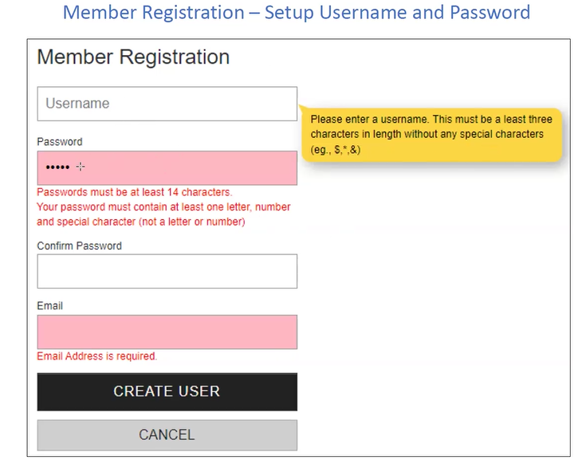

Once you have created your account, the next time you log in, a 5-digit code will be sent to your email. This will only need to be provided once every 30 days.

Member Payment Experience
You can be select the links to access the videos regarding payment process:
- Online Credit Card Payment – Member Perspective
- Online Bank Account Payment – Member Perspective

Videos also available under Help

How to access the mobile application for your smart phone:

Your ClubHouse Online mobile app is now ready. To download, go to Apple or Google Play store, search for “ClubHouse Online Mobile App” to install.
You will need to register on the website before you can log into the app.

